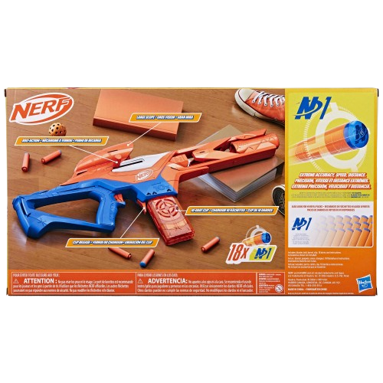****

**Nerf N Pinpoint**

**Price: $19.99**

**Enjoy every Nerf pin points design**

**Interactive and detailed LEGO components**

**The Nerf N-Strike Elite Pinpoint Sight is a precision accessory designed to enhance your Nerf blaster's accuracy and targeting. This tactical sight attaches easily to most Nerf blasters, allowing players to line up their shots with greater precision. Featuring a red dot sight**

**.**

.

**Product details**

**THANK YOU!**

**WELLCOME TO OUR WEBSITE**